# Overview

In this guided practice you will download and deploy the software in our software share using group policy.

# Objectives

* Be able to publish software using group policy.
* Be able to assign software to users or computers using group policy.

# Prerequisites

* Guided practice - **Creating Active Directory Objects** is complete.
* Verify that \\absdc1\software share exists and that **ABSDC1-Software-R** group has **Read** permission to the share.

# Scenario

ABS Corporation requires all software to be deployed remotely using **Group Policy**. In this guided practice you will configure **Group Policy** to assign software to individual users and computers and publish software for later installation by users.

# Tasks

## Publishing software with group policy

Publishing software using group policy allows users to install software on demand. The software does not get automatically installed. The user must choose to install the software from the Programs and Features applet in the control panel.

Publish the **MBSA** software using group policy:

1. Logon to the **CIS256-DC1** virtual machine (**ABSDC1**) using the **absadmin** account.
2. 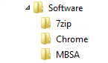Create a folder named **Chrome**, **7zip**, and **MBSA** in the **c:\shares\software** folder.
3. Download the **7-zip**, **MBSA**, and **Google** **Chrome** msi files from the course website and place them in the associated folders that you created above.
4. Open the **Group Policy Management Console**
5. Navigate to the **Forest: abscorp.com à Domains à abscorp.com**
6. Select **Create a GPO in this domain, and Link it here…** from the **context menu** for **abscorp.com.**
7. In the **New GPO** dialog box, **name** the Group Policy - **ABS Corporation Software Installation** andclick **OK**.
8. Right**-**click the policy you created and select **Edit** from the context menu.
9. Navigate to the **User Configuration à Policies à Software Settings** node.
10. Select **New à Package…** from the **Software installation context** menu.
11. In the **address bar** for the file browser type **\\ABSDC1.abscorp.com\software**.
12. Browse to the **MBSA folder** and select the **MBSA installer package,** as shown in the figure, and click **Open**.
13. 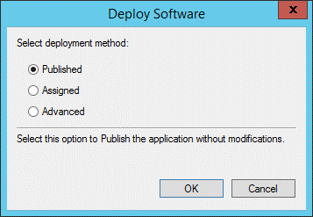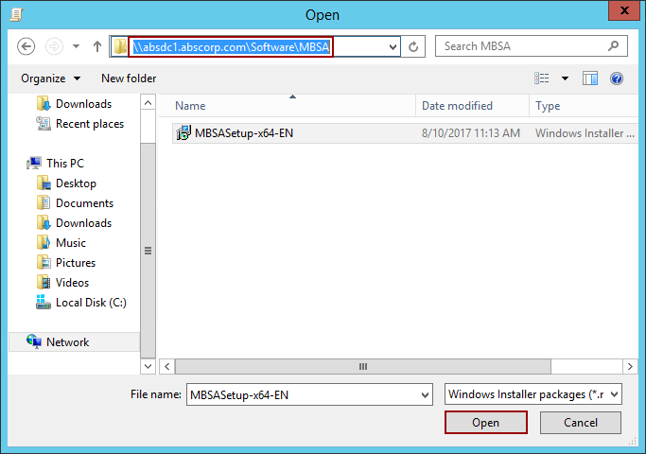In the **Deploy Software** dialog box **verify** that **Published** is selected and **click OK**.
14. 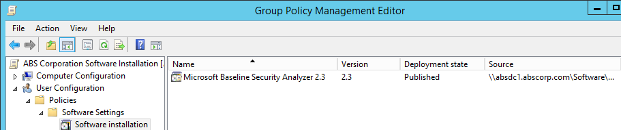Verify that the package shows in the display window as shown below.
15. Close the **Group Policy Management** Editor.

Verify the software has been published using the steps below:

1. Start the **CIS256-Client1** VM and **logon** using any account.

**Note:** If a user is already logged on, the user must log out and then back on again.

1. Open the **Programs and Features** (**Start 🡪 Settings 🡪 Apps 🡪 Programs and Features**)
2. **Choose** the **Install a program from the network** option.

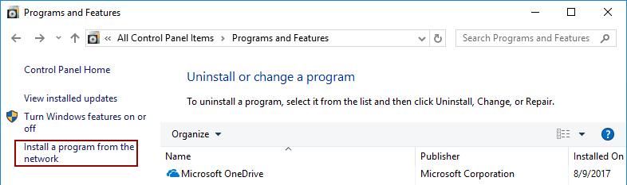

1. You should see the screen below that will allow you to install Microsoft Baseline Security Analyzer on your machine.

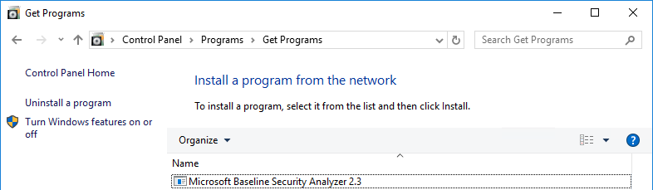

1. **Select and install Microsoft Baseline Security Analyzer** to test the remaining settings.

## Assigning Software to computers

Assigning software to computers through Group Policy will result in the software being installed on the machine when a computer restarts. In this step you will assign the Chrome software to all the computers in the domain

Assign the **Chrome** software to all the computers using Group Policy:

1. Logon to the **CIS256-DC1** virtual machine (**ABSDC1**) using the **absadmin** account.
2. Open the **Group Policy Management Console**
3. Navigate to the **Forest: abscorp.com à Domains à abscorp.com**
4. Editthe **ABS Corporation Software Installation** policy.
5. Navigate to the **Computer Configuration à Policies à Software Settings** node.
6. Select **New à Package…** from the **Software installation** context menu.
7. In the addressbar for the file browser type **\\ABSDC1.abscorp.com\software**.
8. Browse to the **Chrome** folder and select the **Chrome installer package** and click **Open**.
9. 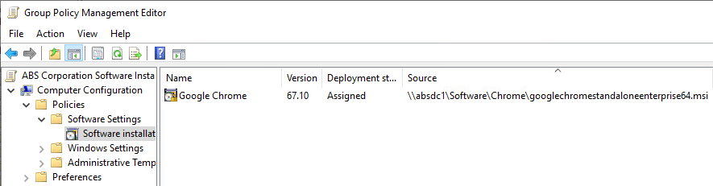In the **Deploy Software** dialog box **verify** that **Assigned** is selected and click **OK**.
10. Verify that the package shows in the display window as shown below.
11. Browse to the **Computer Configuration à Policies à Administrative Templates à System à Logon**
    1. **Enable** the **Always wait for the network at computer startup and logon** policy, this will force the computer to process your group policy objects at startup or logon, which may slow things down some but will minimize the number of reboots required to get software installed.
12. Turn on the group policy for verbose messages. This will give you detailed messages about what is occurring during startup and logon. Perform the following:
    1. In the GPO, browse to the **Computer Configuration à Policies à Administrative Templates à System**
    2. **Enable** the **Display highly detailed status messages** policy.
13. Close the **Group Policy Management** **Editor**.
14. Add the **Domain Computers** group to the **ABSDC1-Software-R** group to give the computer permission to read the **Chrome** installer package.

Verify the software has been installed using the steps below:

1. Logonto the **CIS256-Client1** virtual machine using any user account.
2. Verify that **Chrome** is **installed,** you should see an icon on the desktop.
3. If **Chrome** did not install, perform the following:
   1. Open **PowerShell**
   2. Type **gpupdate /force**
   3. Sign out and sign back in or restart if prompted.
4. Logonto the **CIS256-Client1** virtual machine to verify the policy configuration.

## Submission Requirements

1. **Download** the **grading** **script** from the assignment page to the **C:\Scripts** folder.
2. Check your lab by running the following command:

Invoke-Pester -Path C:\Scripts\ GP18-Deploying_Software_with_Group_Policy test.ps1

**Note**: You will see a security warning when running the script. Enter **R** to run the script.

If you want to see more detail, add **-Output Detailed** to the command. This may assist you with troubleshooting

Invoke-Pester -Path C:\Scripts\ GP18-Deploying_Software_with_Group_Policy test.ps1 -Output Detailed

1. You should not see any red in the output. Red in the PowerShell way of telling you that an error condition exists. Most of the time, the output will tell you what is wrong. If it is not obvious, contact your teacher and ask for assistance. You will be learning PowerShell during this term. **Correct** any **errors** you may have and run the script until all the output has no red. You should see the output like the images below.

1. Capture a snippet that shows the PowerShell Command and all its output. If you must use more than one snippet to capture the output, you must have at least **one line of overlap** in the snippets. The text in the snippets **must be legible** when pasted into the Word document. Paste the snippet(s) into a **new** **Word** **document.** Save the file as **DeploySoftware_*Firstname*_*LastName*** (where ***Firstname*** is your first name and ***Lastname*** is your last name).
2. **Upload** the **document** in the submission area of the assignment.